**ESSAY WRITING - KEY CONNECTIVES**

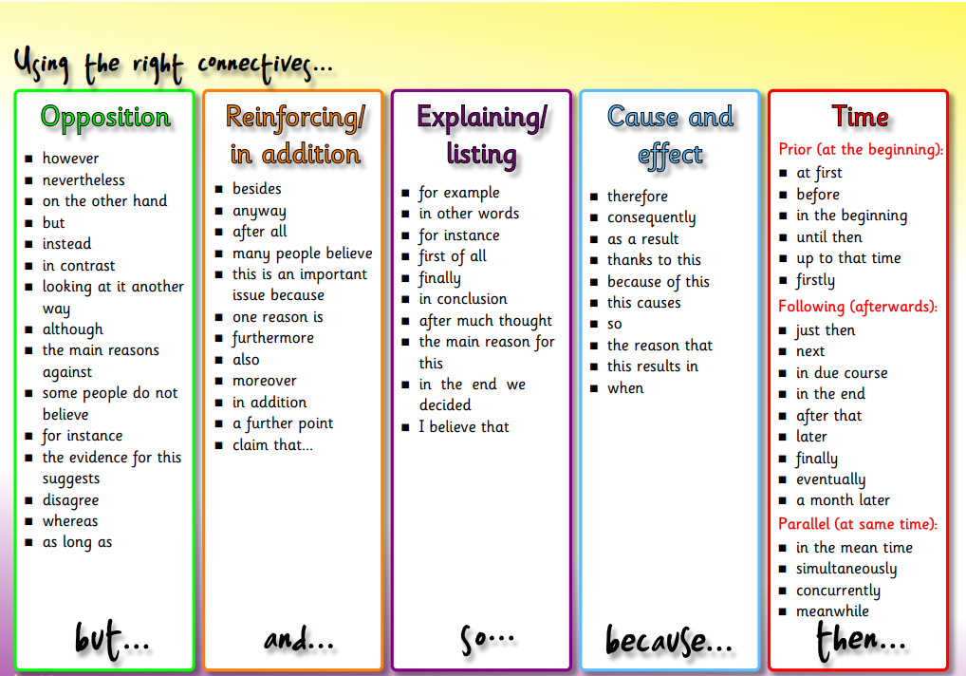

**ESSAY WRITING OPINION WORDS AND PHRASES**

